STATUS REPORT OF
CREATING A CLUSTER COMPUTING ENVIRONMENT TO ADDRESS COMPUTATIONALLY INTENSIVE PROBLEMS IN COMBUSTION

The objective of this project is to explore possibilities of using a cluster computer system constituted of 28 Intel processors to carry out parallel computations. Examples of computations include problems in reacting transient jets, emissions, sprays, combustion and flows in internal combustion engines, furnaces and other applications. On a serial processor, these take several days. Within the cluster environment, parallel computations of these problems would be carried out using processors that have distributed memory (single processor machines communicating via a network) as well as shared memory (multi-processor machine). To date, both of these approaches have been explored. It has been found that the multi-processor, single machine arrangement is the most convenient, though the full potential of the distributed memory arrangement is yet to be realized.
As one example of a computation carried out, the Figs.1 and 2 shown below are taken from the paper “Parallel computations of turbulent incompressible jets”, V.Iyer, J.Abraham and V.Magi, Proceedings of the High Performance Computing Symposium – HPC 2000, pp. 3-8, Washington D.C., 2000. Figure 1 shows the computational grid used to model the problem. Fig. 2 shows the speedup, efficiency and effectiveness of the computations on a quad-Pentium, which belongs to the cluster project. It has been observed that a speedup of about 2.5 over the serial computation can be obtained on a quad-Pentium for a grid resolution typical to this problem. On the other hand, significant gain in speedup has not yet been obtained when the parallel computations are run across distributed memory processors owing to relatively large overhead in communication. As another example, Fig. 3 shows the computed flow field in a Diesel engine indicating injected fuel contours and velocity vectors.
Work is in progress in developing algorithms for parallel computation of flows, combustion and sprays in internal combustion engines and other applications on the cluster.
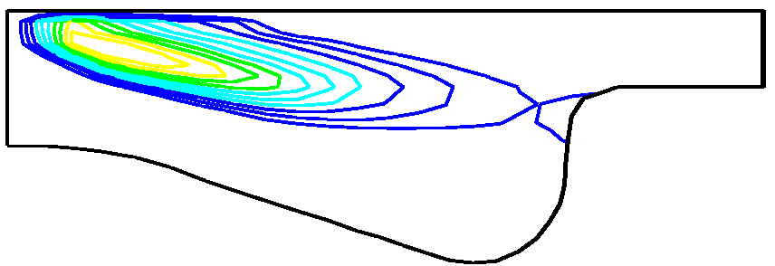
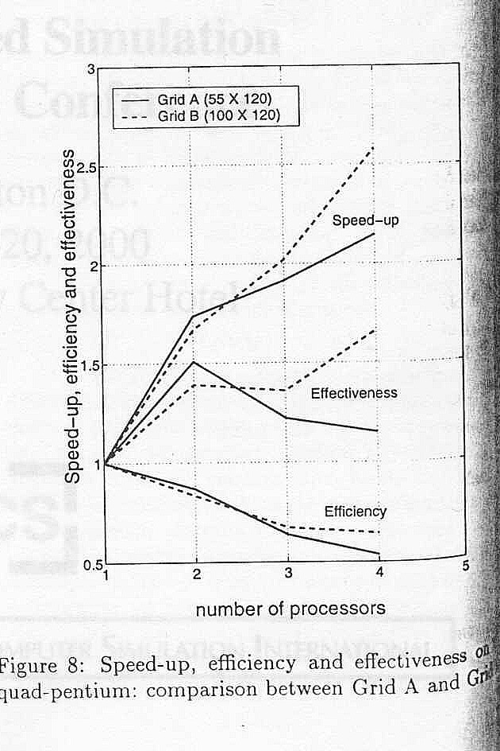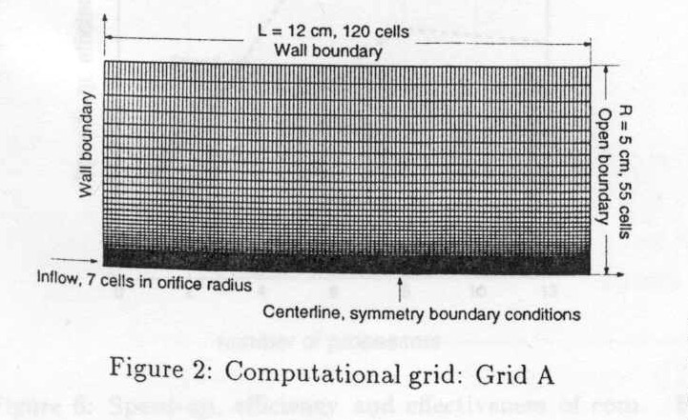Figure 1 Computational grid for transient jet Figure 3(a) Side view of Diesel combustion chamber showing fuel contours
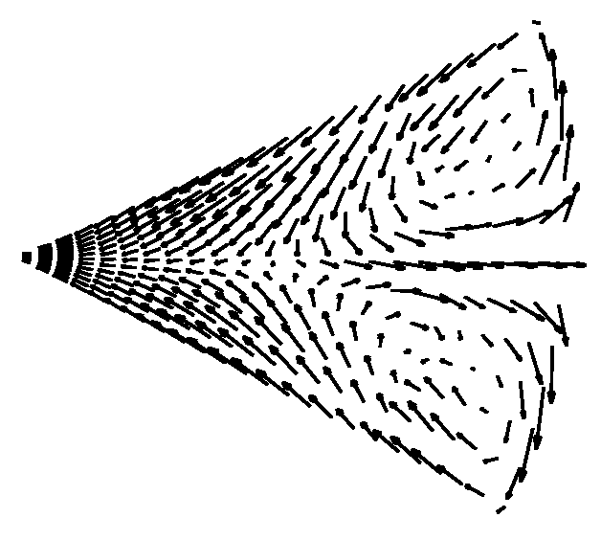
Figure 2 Speedup-factors on a quad-Pentium Figure 3(b) Top view of Diesel combustion chamber showing velocity vectors

