Course Features
Training Donated by

Planning, Installing & Configuring Windows® 2000
in a University Computing Environment

Course length is tailored to your requirements
Note: This course is taught by a Microsoft Certified Instructor using Microsoft Official Curriculum.
Who should attend
This course is intended for departmental Information Technology professionals from Computer Science, Engineering, and Business schools who will be responsible for planning, deploying, and administering Windows 2000.
Prerequisites
- Operating systems background (e.g. UNIX®, Windows® NT®, Windows® 95/98, or equivalent operating system experience).
- A working knowledge of clients, servers, local area networks, drivers, protocols, and network operating systems.
What course provides
This course provides departmental Information Technology professionals with the introductory knowledge and skills necessary to plan, install, and configure Microsoft Windows 2000 in a University computing environment.
What students learn
At the end of the course, students will be able to:  - Identify the capabilities and benefits of the operating systems included in Microsoft Windows 2000  - Describe how to install Windows  - Explain troubleshooting installation  - Describe installing, configuring, and testing the DNS Server service  - Describe the logical and physical structures of Active Directory, and install Active Directory  - Explain how to modify Active Directory physical structure, and monitor replication traffic  - Describe Active Directory administration  - Plan for hierarchical design of Active Directory structure to support  - Explain how to upgrade Windows client operating systems to Windows 2000  - Explain how to upgrade member servers to Windows 2000  - Describe how to establish the forest root for the Windows 2000 Active Directory service  - Explain how to upgrade domain controllers to Windows 2000  - Describe how to switch a domain from mixed mode to native mode  - Discuss how to provide access to shared folders by using a distributed file system (DFS)  - Describe how to manage disk quotas on NTFS volumes  - Describe how to use Encrypting File System (EFS) for file encryption  - Explain the capabilities and structure of Group Policy  - Discuss how to apply Group Policy to manage desktop environments and software deployment  - Describe how to authorize a DHCP server in the Active Directory service, and  - Explain dynamic update of DNS name servers  - Explain how Automatic Private IP Addressing works  - Explain new WINS functionality  - Discuss SAMBA and review materials related to Windows 2000–UNIX interoperability | Delivered by  
What students receive
Each student receives a copy of Microsoft Official Curriculum for post-class reference and review. | 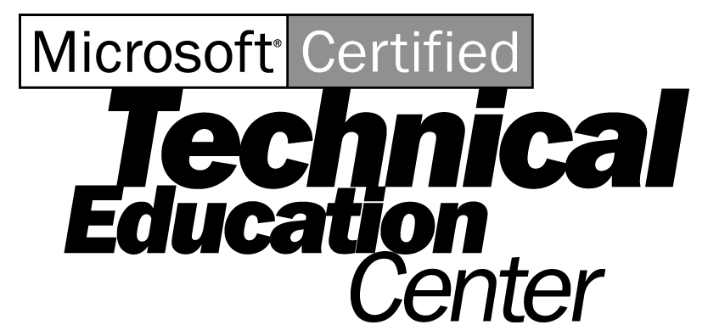

Planning, Installing, and Configuring Windows 2000 in a University Computing Environment Page 2

Course Outline
Introduction to Windows 2000  - Overview of Windows 2000  - Windows 2000 Professional  - Windows 2000 Server and Advanced Server  - Windows 2000 Datacenter Server  Installing Microsoft Windows 2000  - Preparing for installation  - Installing Windows 2000 from a compact disk  - Installing Windows 2000 over a network  - Automating installations by using the Windows 2000 Setup Manager wizard  - Automating installations by using disk duplication  - Performing remote installations of Windows 2000  - Troubleshooting Windows 2000 setup  Implementing DNS in Windows 2000  - Installing the DNS Server service  - Configuring zones in Windows 2000  - Testing the DNS Server service  Installing Active Directory  - Introduction to Active Directory  - Logical structure  - Physical structure  - Specific domain controller roles  - Installing Active Directory  - Verifying Active Directory installation  - Managing single master operations  - Using the domain administrator account  Creating the Physical Structure of Active Directory  - Exploring the physical structure of Active Directory  - Implementing the physical structure of Active Directory  - Monitoring replication traffic  Administering Active Directory  - Creating and managing Active Directory objects  - Managing groups  - Controlling access to Active Directory objects  - Adding object attributes to the global catalog  - Delegating administrative control of Active Directory objects  Upgrading a Network to Windows 2000  - Upgrade overview  - Upgrading client computer operating systems  - Upgrading member servers  - Establishing the forest root  - Upgrading primary domain controllers  - Upgrading backup domain controllers  - Switching from mixed mode to native mode |  |  | Configuring File Resources  - Sharing and publishing file resources  - Administering shared folders by using a distributed file system (DFS)  - Configuring offline files  - Managing disk quotas on NTFS volumes  - Increasing security with Encrypting File System (EFS)  Using Group Policy to Manage Desktop Environments  - Introduction to Group Policy  - Applying Group Policy  - Examining the Group Policy interface  - Configuring the registry by using Group Policy  - Assigning scripts by using Group Policy  - Redirecting folders by using Group Policy  - Guidelines for implementing Group Policy  Using Group Policy to Manage Software  - Examining software deployment  - Exploring software management technologies  - Examining the software life cycle  - Deploying software  - Upgrading software  - Removing software  - Managing software  - Identifying solutions to software deployment problems  Supporting DHCP and WINS  - New DHCP functionality  - Authorizing a DHCP server in Active Directory  - Examining dynamic update of DNS name servers  - Configuring DHCP scopes in Windows 2000  - Examining options classes  - Examining Automatic Private IP Addressing  - New WINS functionality  Security  - Discussed throughout various modules  Windows 2000-UNIX Interoperability  - Discussing SAMBA  - Reviewing white papers and other materials that address Windows 2000 and UNIX interoperability

