BITS C461 Software Engineering
First Semester 2003-2004

Project Requirements

Smart Tester™ - A Platform for Creating & Administering Online Tests Based on “Test-by-Doing”

Project Sponsor

K R V Subramanian
CEO
AnswerPal Private Limited
1-5 Richmond Towers
12 Richmond Road
Bangalore 560025
Background on Online, Technology Based Testing

A vast majority of the software platforms that provide online, technology based testing limits themselves to tests based on “multiple choice answers”. A few platforms offer scope for having tests that elicits a single, simple word or phrase as an answer. Still others offer a slightly “higher degree of sophistication” in terms of ability to elicit responses through matching of two (or more) sets of data.

When such online tests are employed for testing one’s programming skills/techniques, their effectiveness is fairly limited. To begin with, such tests cannot adequately test a person’s problem solving skills (one that both the academia and the industry are keenly interested in). The programming skills (coding skills) of a person cannot be ascertained through such limited instruments. Modern applications require the creation of Graphical User Interfaces (GUI), use of database connections, and a host of other such things. Clearly, testing a person’s capability of developing GUIs through a set of multiple choice tests can be futile. Today, most of the application development requires one to make use of an Integrated Development Environment – a sophisticated piece of software that embodies a programming language as just a simple component. Examples are Microsoft Visual Basic.NET and IBM’s Visual Age for Java, among others. There is a definite case for having an online testing environment that goes beyond simple multiple choice questions.

Main Objectives

The main objectives of this project are:

- To design and develop a software platform for creating and administering of online, technology based testing systems - codenamed Smart Tester™
- To provide in the platform a wide variety testing instruments including multiple choice type questions, questions that elicit a simple phrase as answer, questions that require matching of sets of data, and even handling code snippets
- To provide an ability to create and administer “task based testing” that is based on the principle of “testing by doing”
- To provide a fairly sophisticated, customizable evaluation and reporting system that highlights the relative strengths and weaknesses of the candidates

“Testing by Doing” requires the candidate to perform tasks on the actual product / environment. The evaluation is based on what actually the person does in response to the tasks given. Indeed, Martin Bean, in his article entitled “The Future of Testing” states that “Simulation-based or real-time, lab-based test questions will be the dominant alternative to multiple-choice exam questions. The industry, the learner and the employer are demanding more effective ways to test real-world skills”.

Basic Features of Smart Tester™

Smart Tester™ caters to three visible, operational entities:
- Entities that creates tests and testing systems (test developers, publishers, authors, psychometric specialists, etc.)
- Entities that administers various tests and testing systems (certifying bodies, HR executives in companies, faculty in educational institutions, etc.)
- Entities that take the tests (candidates)

For each of these entities, the areas of specific interest and operations are given in Figure 1 below.

The following constitutes a set of basic features, a wish list if you will, of the Smart Tester™. The list does state in a simple way a set of requirements that the platform must meet, albeit in an ambiguous and incomplete manner.

As Seen Through the Eyes of the Entity that Creates Tests-Testing Systems

- The ability to develop (author) a new test for a specific subject, situation or environment
- The platform must provide for the ability to create test items (questions-teaks) based on
  - Multiple choice tests
  - Questions that elicit a simple phrase as an AnswerPal
  - Questions that require data from two or more sets to be matched
  - Tasks to be performed
- The platform must also provide the capability for the test developer to define the correct answer(s) to the question, define the acceptable ways of performing tasks, etc. This normally would serve as the basis for evaluation.
- The platform must provide for the ability to the test designer to state the performance requirements and performance statements, which may be used to provide feedback and performance reports.
- The platform must be capable of allowing for update and maintenance of the list of questions, tasks, and associated items of a test.
- The platform must be generic enough to be able to create tests for any software application that runs on Microsoft Windows OS (2000, 98 and XP versions), such as Visual Basic.NET, IBM Visual Age for Java, Microsoft Office Products, etc.
- The platform must provide the test designer to store and retrieve tests from a central repository that can be archived, if necessary.

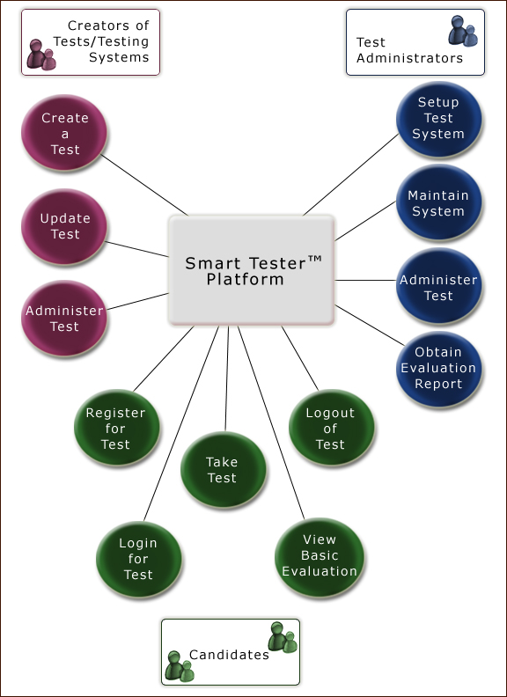
Figure 1: Entities and Operational Interest in Smart Tester™

- The platform must provide for the specification and operation of an access control mechanism for the test and test items.

As Seen from the Eyes of the Candidate

- The system must allow a candidate to be able to register for a test. The process of registration must be secure, simple and easy to use
- The candidate must be capable of logging into a test. All the features of a test that is available to a candidate are accessible only after successful login.
- The platform must display the rules, regulations, terms and conditions, as well as instructions clearly to the candidates. The candidates must explicitly state hat they have read each of these and that they accept to be bound by what is stated therein.
- A candidate would have a capability to watch a short, self-run demo of the test process.
- Before the candidate starts off a test, the platform provides for a “practice set of questions”. These practice questions would normally provide for a few questions-tasks representative of the variety of test items used in a test. The candidates’ responses would be tracked, evaluation done, and feedback provided. However, these are all for practice purposes only and not used in the actual test and evaluation.
- A candidate must clearly indicate by exercising an option to begin the test. A timer would begin tracking the elapsed time and help in controlling the duration of a test.
- The questions-tasks in a test would be displayed one at a time, based on a sequence or system or pattern suggested by the test developer.
- Once shown a question-task, the candidate can either proceed to answer it and perform the task or choose to skip to the next question-task. The candidate can return to the skipped question-task later on his/her choice.
- When a task is to be performed, the platform would provide for a “safe mode” to the candidate for carrying out the task. For example, the tasks specified could be “to create a form in Visual Basic to enter data on X, Y and Z and control elements to save the form or cancel the process”. In this case, the platform ought to provide for a capability to perform this task in Visual Basic in a safe mode (safe mode implies that the candidate cannot perform certain things that would destroy certain files-folders in the test environment through neglect, ignorance or malicious intent).
- The candidate would have the ability to revise answers to questions or choose to perform a task again, ignoring the previously saved performance.
- The candidate would be provided a suitable warning, x units of time, before the time for the specific test runs out.
- The candidate must have the ability to complete the test by explicitly indicating that he/she is ready to do so and submit the answers-performance to evaluation.
- When the time runs out, and the candidate has not explicitly exited from the test, the platform must indicate to the user, and seek his/her assent to completion of the test. In any case, the candidate would not have the ability to view, modify or perform any task once the time runs out for a test.
- On conclusion of a test, a simple report would be shown to the candidate. This report itself would be based on the recommendations of the test designer and the customization he/she has built in.
- Once a person has completed a test, the same person cannot take another test unless explicitly permitted by the test administrator on site.

As Seen Through the Eyes of a Test Administrator

- The platform must provide for a repository to hold a number of different tests
- The administrator would have the capability to organize the tests, display the tests (from just name of test to inner details), and perform maintenance tasks on the repository as required
- The administrator would have access to the list of registered candidates, display and update schedules
- When a candidate shows up to take a test, the administrator would have the capability to permit the candidate to login and proceed to take the test
- The administrator would have the capability to resume a test for a candidate from the beginning or from a specific point in response to unforeseen situations
- The administrator would have the ability to generate a detailed performance report of the candidate
- The administrator would have the ability to obtain a variety of statistical reports on the tests
- The administrator would have the ability to extract specific pieces of data on tests, performance, etc. from the repository and export them for use by other entities when required

Some General Requirements

- The platform should be capable of working with tests created around any software application that runs on Microsoft Windows 2000, XP or 98. The platform itself should be as decoupled as possible from the software application itself that forms the basis of a test. In other words, the platform itself should not be tightly bound to the candidate test applications such as Visual Basic.NET or Visual Age for Java or any other.
- The test developer must be provided with a front end that enables him/her to create the test based on any software application, without requiring the test designer to tweak or modify the platform itself.
- The platform itself, along with the repositories must be on a designated server.
- The security of the repository and its contents must be strictly done and enforced through an access control policy
- While the initial version of the platform may provide only for a few types of test items (such as multiple choice, test by doing, etc.), the platform must be flexible enough to accommodate newer emerging test mechanisms in a simple manner. In effect, this must not require the entire platform to be modified.
- Feedback and reporting are the critical aspects of a test process. The components that provide for these must ensure extreme amounts of flexibility to the users for customization.
- It expected that online testing process, psychometric techniques as well as the technologies themselves would become more sophisticated in future. It is expected that the platform itself would be a long lasting product. This necessitates that the architecture and the design be capable of allowing for a number of additions, deletions, etc. – in short, very highly volatile requirements with a stable core.

What Is To Be Done?

Each of the designated teams that is assigned this project by the Instructor-in-Charge would perform the following tasks:

- Requirements Analysis and Specifications
The requirements would be analyzed, refined and written down as a Software Requirements Specification document (following preferably IEEE 830 standards). The specifications may also include a set of use cases, sequence diagrams, and domain model specified in UML.
- Architectural Design
The architectural design would enumerate the list of gross structural components of the system and their inter-relationships. The architectural design document that is to be written would also contain system architecture specification.
- Detailed Design
This stage would involve the design specification of the various components of the Smart Tester™ platform. It is expected that the design be expressed in UML.
- A Working Prototype of Smart Tester™
This working prototype is expected to demonstrate how the Smart Tester™ would function. A sub set of features that the platform would have will be showcased.

