Birla Institute of Technology & Science, Pilani, India
First Semester 2003-2004
Software Engineering (BITS C461/ IS C341)
Laboratory Assignment No. 1
Date: 19/08/2003 | Deadline: 26/08/2003 11pm | Weightage: **
Deliverable: Microsoft Word 2000 Document (*.doc)
Mode of submission: Upload through http://intrabits.bits-pilani.ac.in web site

♫ | Objectives:
- Learn Rational Rose
- Get to work with Rational Rose
- Test and hone your skills

♫ | Requirements:
- Rational Rose (certain fixed terminals at IPC would have it installed)
- Prior knowledge about what a use-case diagram is.
- Scratch paper and pen/pencil.
- A cool head.

♫ | Rational Rose:
So, after all the brouhaha about proper design of software, we are at a stage where we could practically and tangibly develop designs. One possible solution to make your design tangible is to make UML (Unified Markup Language) diagrams on paper and secure it. Another solution would be to draw the UML diagrams using editors like MS Word™ etc. But these solutions are tedious and not dedicated and user-friendly solutions for UML diagramming and documenting. Is there a dedicated tool for developing UML diagrams?? The answer is YES! Rational Rose is a tool that could be used to develop UML diagrams at ease. This exercise should take about an hour and a half at a comfortable pace. So sit back and enjoy learning Rational Rose.

Why Rose??:
There are a number of reasons to use Rational Rose for your development work. Here are just a few:
- Model-driven development results in increased developer productivity.
- Use-case and business-focused development results in improved software quality.
- Common standard language--the Unified Modeling Language (UML) --results in improved team communication.
- Reverse-engineering capabilities allow you to integrate with legacy OO systems.
- Models and code remain synchronized through the development cycle.

The first step:
The first diagram that we will look at is a use-case diagram. Now, though I had vetoed against drawing the diagrams on paper, it would be highly helpful if u have done some work on your scratch paper before trying your hand at Rose. So, once you are ready with some scratched draft of your use case diagram on paper, start Rose.

The Rose graphical user interface:
You may already be familiar with a number of graphical user interface (GUI) conventions used in Rose. The most common elements are:
- Standard toolbar
- Diagram toolbox
- Browser
- Diagram window
- Documentation window
- Specifications
These items are briefly discussed in subsequent slides. How, where, and why each of these elements is used will become clearer as you progress through the sheet.

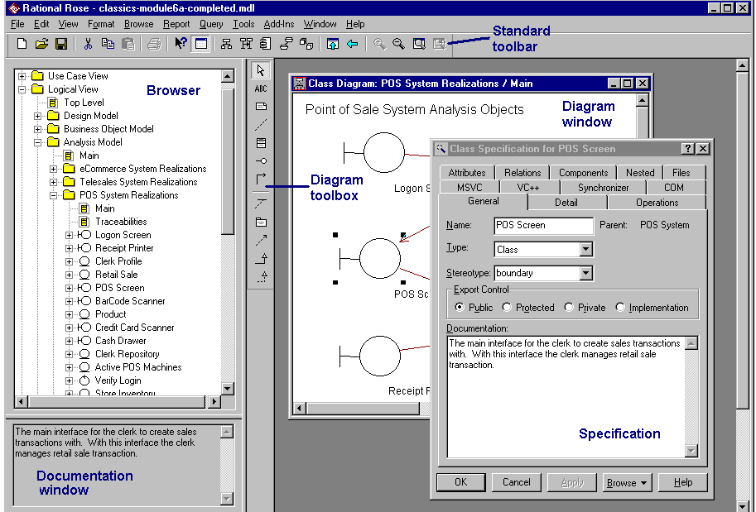

Toolbars and toolboxes:
The Rose standard toolbar is located near the top of the window and is always displayed - independent of the current diagram type. While in Rose, place your cursor over the toolbar to display a tool-tip for each icon. The Rose diagram toolbox changes based on the active diagram. (The active diagram is the one displayed with a blue title bar.) As with the standard toolbar, placing your cursor on an icon displays the tool-tip for that icon.
You can drag and drop the required use case item (like actor, use case, association etc) on the active diagram. You can rename each of the items on the drawing. You can arrange them by dragging the items.

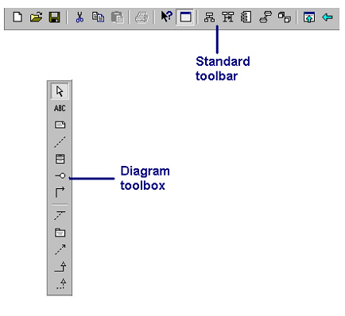

The diagram window:
You can create, display or modify Rose diagrams in the diagram window. If you have multiple diagrams open at one time, they are either displayed in a cascading or tiled view.A cascaded window layers multiple diagrams on top of one another with only the title bar showing for all but the top most diagram. A tiled window divides the application window into equal-sized areas and all diagrams are visible.

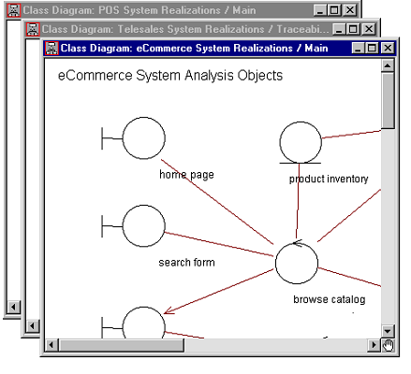

The browser:
The Rose browser is a hierarchical navigational tool allowing you to view the names and icons representing diagrams and model elements. The plus (+) sign next to an icon indicates the item is collapsed and additional information is located under the entry. Click on the + sign and the tree is expanded. Conversely, a minus (-) sign indicates the entry is fully expanded. If the browser is not displayed, select Browser from the View menu.

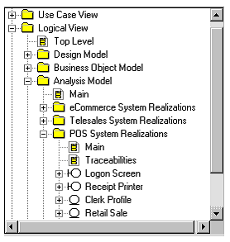

The documentation window:
The documentation window allows you to create a self-documenting model and from that self-documenting model generate self-documenting code. You can create, view or modify information here or in the documentation window of the specification. If the documentation window is not visible, select Documentation from the View menu. If there is a check mark next to Documentation and you still can’t see the window, move your cursor to the bottom of the browser. When the pointer cursor changes to a splitter cursor, drag up on the browser window to display the documentation window. This window is updated as you select different elements on the diagram.

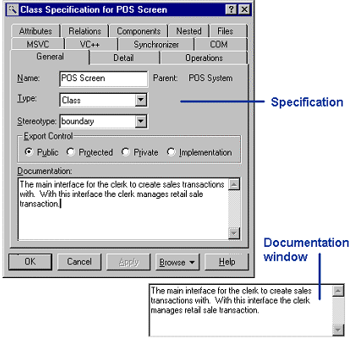

Views:
Just as there are many views of a house under construction – the floor plan, the wiring diagram, the elevation plan, there are many views of a software project under development. Rational Rose is organized around the following views of a software project:
- Use Case
- Logical
- Component
- Deployment
Each of these views presents a different aspect of the model and is explained in subsequent slides.

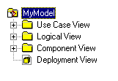
The use-case view:
We will be concerned about the use-case view only for this session. The use-case view helps you to understand and use the system. This view looks at how actors and use cases interact. The diagrams in this view are:
- Use-case diagrams
- Sequence diagrams
- Collaboration diagrams
- Activity diagrams
This view contains a Main diagram by default. Additional diagrams can be added throughout the analysis and design process.

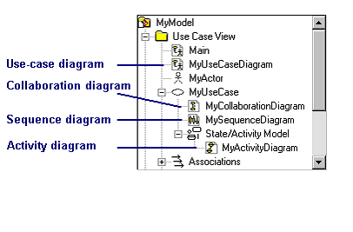
Use-case diagrams:
Use-case diagrams present a high-level view of system usage as viewed from an outsider’s (actor’s) perspective. These diagrams show the functionality of a system or a class and how the system interacts with the outside world. Use-case diagrams can be used during analysis to capture the system requirements and to understand how the system should work. During the design phase, use-case diagrams specify the behavior of the system as implemented. Rose automatically creates a Main use-case diagram in the use-case view. There are typically many use-case diagrams in a single model.

How to copy the diagram to Word:

After you finish drawing the diagram in Rose, you can copy the entire diagram into word by copy-pasting it. The two usual ways are.
1)
- Press ctrl + a to select all items in the drawing (in Rose)
- Press ctrl + c to copy
- Open a Word document
- Press ctrl + v to paste it
2)
- Press ctrl and select all the objects that you want to select from the drawing by left clicking (with the mouse)
- Right click the selected objects and select copy from the pop-up menu
- Open a word document
- Right click on the word document and select paste to paste it.

Getting help:

As you work with Rational Rose, you can get additional help in the following ways: The Help button:
Click this button to display help for a specific dialog box or specification.
What’s this:
Click on the ? located on upper right corner of many dialog boxes. Then click on an area for which you want a brief description.
F1 or context-sensitive help:
Press F1 or the large ? on the Rose toolbar to get information on the area of interest.
The Help menu:
Click this menu to display a list of online documentation subjects.

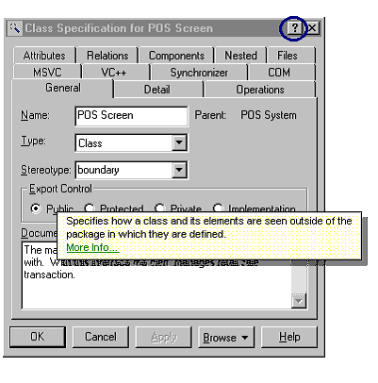

♫ | One sample problem:
Requirement:
One exacting educational institute wanted to keep track of each student’s attendance record and bug her/ him with warnings to attend classes if she/ he does not. It is assumed that each student has a mobile phone and that they are reachable by the system (using software) at anytime anywhere. Also, each student will wear a “pin” that will uniquely identify him. The institute can keep track of the student’s current location using ubiquitous sensors and the pin. So, the system administrator will keep checking each student’s location from 8am to 5pm. Each student will also have a specific time-table to attend classes. If the student is not at the prescribed class at any specific time, the system will keep sending messages to her/ his mobile phone (obviously asking her/ him to go to the class). The student could reply back to the administrator with an excuse. If the system administrator finds the student’s excuse invalid or she/ he is not responding, the administrator will send a message to the Instructor-In-Charge of that course with the ID of the student and other details (these messages will be stored by the IC for evaluation). The IC has to reply to that message for confirming receipt. Now, they want you to design a portion of the system by drawing a use-case diagram for the same. The institute’s Object Oriented Analysis and Design experts have identified some use cases and their actors. You need to draw these in Rational Rose.

Use case | Actors
Track Student’s Location | Administrator
Get prescribed locations of students | Administrator
List out-of-location students (uses “Track Student’s Location” and “Get prescribed locations of students” use-cases) | Administrator
Send Message | Administrator
Send Message to students (extends from “Send Message” use-case) | Administrator
Send Message to IC (extends from “Send Message” use-case) | Administrator
Reply to Message | Administrator, IC and student
Reply with excuse (extends from “Reply to Message” use-case) | Student
Reply for confirmation (extends from “Reply to Message” use-case) | IC
Store student details | IC

