INDURE: Indiana Database for University Research Expertise

Instructions for Populating the INDURE Database
Prepared by: Aditya P. Mathur
Original version: May 26, 2008
Last update: June 18, 2008

Heads of Departments: If you want to appoint someone in your department to map faculty to research areas and enter faculty related information, please send a request to your INDURE institutional representative:
Ball State University: Michael Halbrook [mlhalbrook@bsu.edu]
Indiana University:
Purdue University: Aditya Mathur
University of Notre Dame: Terri Hall [mailto:Hall.74@nd.edu]

IMPORTANT (READ THIS FIRST):

- The INDURE effort aims at creating a comprehensive online database of ALL faculty researchers at academic institutions in the state of Indiana. Department heads, and/or their assistants, in participating state academic institutions are requested to complete the following tasks for each faculty member in their department.
- (Push) Map your faculty to all relevant research areas, not only to the field(s) most closely associated within the department. Task 3 below can help you accomplish PUSH.
- (Pull) For each research area closely associated with the department, map all relevant members of your faculty from other departments to that area. Task 5, together with Tasks 3 and 4 can help you accomplish PULL.
Summary:
To perform this task… | See instructions under..
Log into INDURE | Task 1
Log out of INDURE. | Task 2
Assign Research Areas to Faculty | Task 3
Add a new research area to INDURE | Task 4
Assign a research area to multiple faculty | Task 5
Add a faculty member | Task 6
Update faculty information: Admin status, Faculty status, Email, Keywords, Department, URL | Task 7
View all assignments for faculty in your department (for department heads) | Task 8
Add a Keyword List | Task 9
Add a new Appointment Type | Task 10
Add a new College | Task 11
Map an existing Department to a College | Task 12

Instructions

Task 1: Log into INDURE.

- Go to http://www2.itap.purdue.edu/indure/
- Pull down the Login menu located near the upper right corner.
- Select your university/college.
- Type in your login credentials.
- The authentication system of your university will check your credentials and accordingly log you in. Contact your university’s INDURE institutional representative in case of any difficulty.
Screen 1: Login

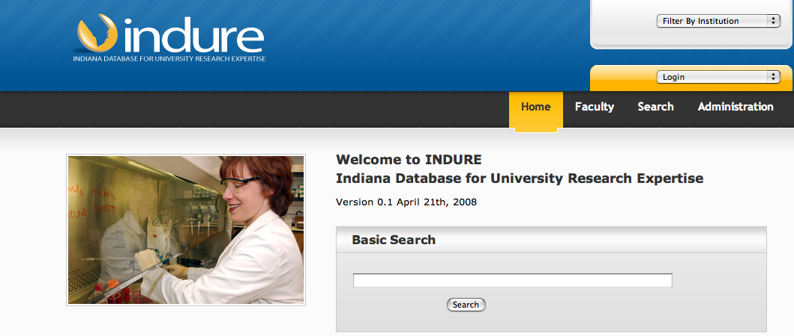

Task 2: Log out of INDURE.
- After you have logged in to INDURE, the “Login” tab will changer to “Logout.” Click on the Logout tab to log out of INDURE.

Task 3: Assign Research Areas to Faculty

- Log into INDURE. If you are already logged in then simply click on the “Administration” tab located towards the top right of the screen and go to step 3.
Screen 2: Administration
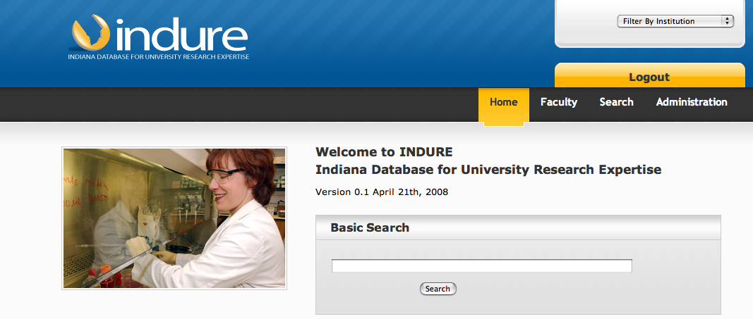
- Click on the “Administration” tab located towards the top right of the screen.

- Click the "Faculty" tab.

Screen 3: Faculty

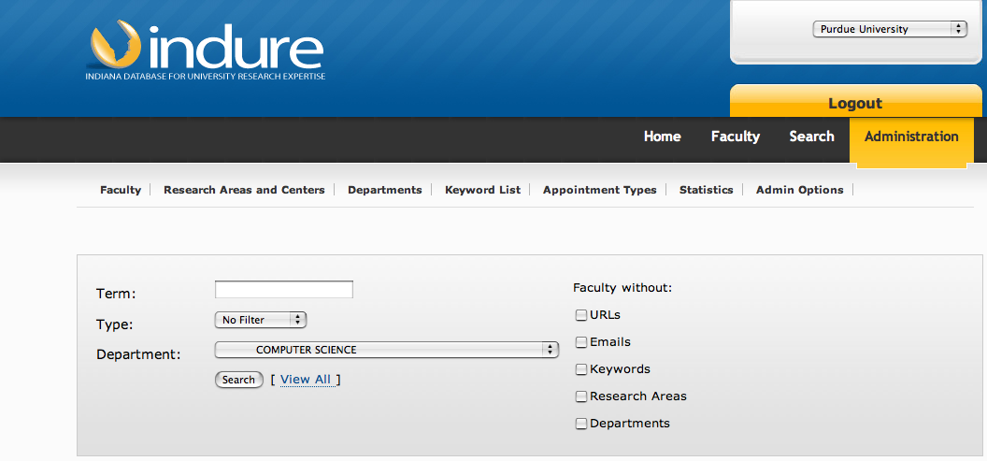
- From the “Department” pull down menu select the department of interest. Click the “Search” button. You should now see a list of all members of the faculty in the selected department.
Screen 4: Faculty Edit

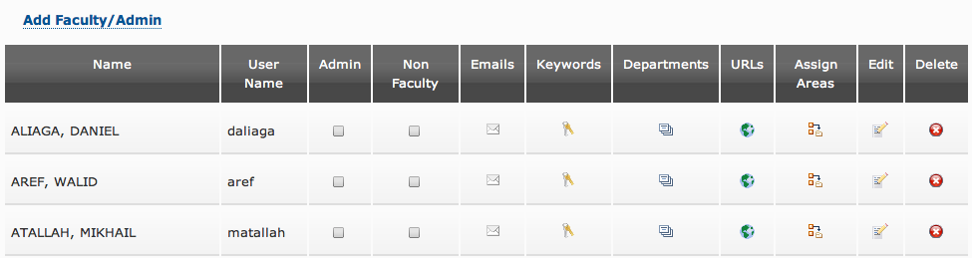
- Starting at the “Admin” and ending at the “Delete” tab, the faculty display screen consists of nine distinct tabs that allow you to edit a variety of information about a faculty member. Select a tab that corresponds to the type of information you want to edit. For example, to assign a research area, select the “Assign Areas” tab.

Caution: Use the “Delete” tab with extreme caution, as clicking on it will delete all information on the selected faculty member.

Screen 5: Research Areas

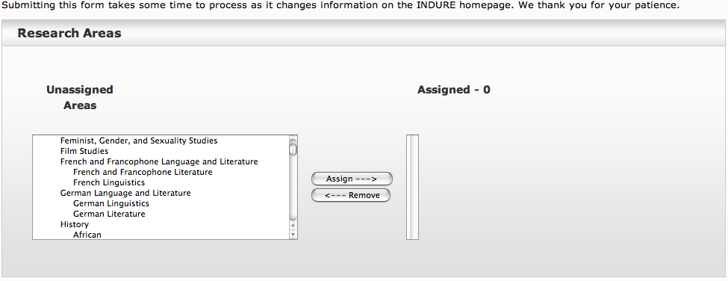
- In the areas box on the left is a list of all research areas currently in INDURE. You may select up to 10 distinct areas to assign to a faculty member. Select an area by clicking on it or by CTRL clicking on it when selecting multiple areas. Then click the “Assign” button to the right of the areas box. In a few moments the selected areas should appear in the box towards the right.

Screen 6: Assign Research Areas

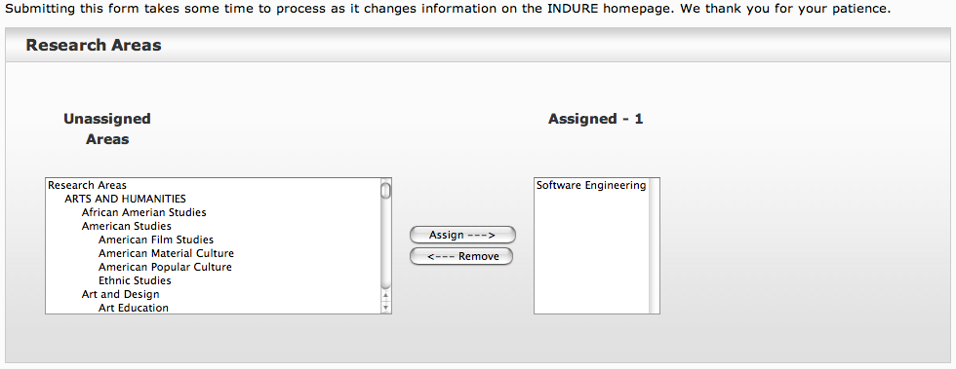
- After completing the assignment of research area, click on the “faculty” tab to return to the “Faculty” screen.
- You may now edit additional information for the selected faculty member or proceed to edit information on another faculty member.

Task 4: Add a new research area to INDURE

- Login to INDURE if not already logged in, and execute steps 1 and 2 in Task 3 above.
- Click the tab "Research Areas and Centers." This leads you to a screen that shows all research areas currently in INDURE.

Screen 7: Add Research Area or Center
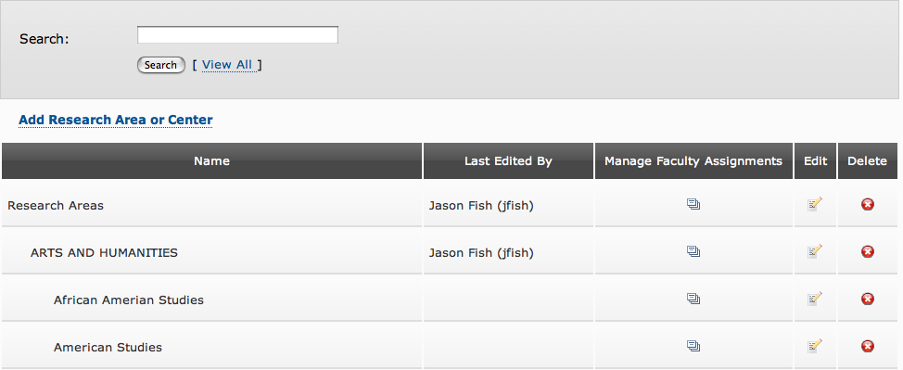
- Scroll down the list and make sure that the area you want to add to INDURE does not already exist. There is a good chance that an existing area is identical to very close to the area you wish to add. If you do not find a matching area, then click on the tab “Add Research Area or Center.”

Screen 8: List of Research Areas
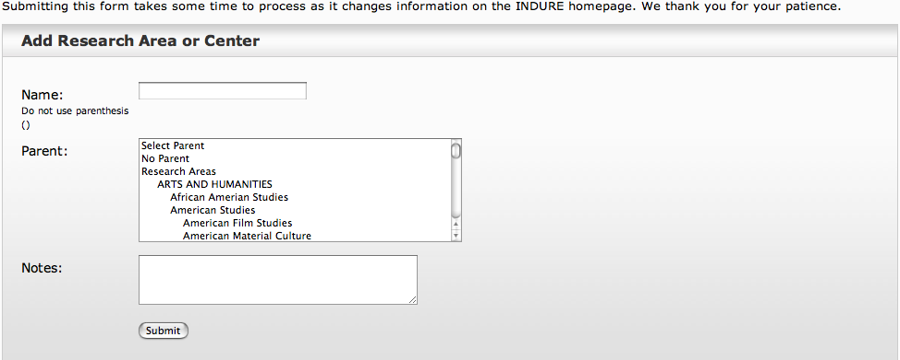
- Type in a brief name of the research area you want to add to INDURE. Then scroll down the box in the center of the screen and select a parent area for the new research area that you want to add. It is important that you select the parent carefully so as to maintain an appropriate hierarchy of research areas in INDURE. Also add a brief note in the box labeled “Note” indicating your name, affiliation and the date when you added a new research area.

Screen 9: Research Area Added

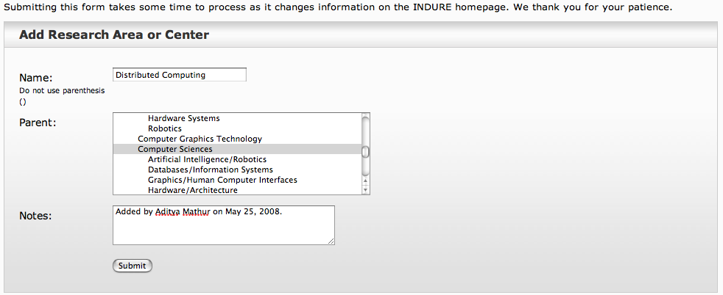
- Click on the “Submit” button. The new research area will now be added to the existing list of research areas and you will return to the screen that shows all research areas in INDURE.

Task 5: Assign a research area to multiple faculty

- Log into the database as described in Task 1 and go to Step 2. If you are already logged in then simply click on "Administration” and go to Step 3.
- Click on the tab labeled "Administration".
- Click on the tab labeled "Research Areas and Centers.”
- You will now see the list of all Research Areas and Centers included in INDURE. Select a research area or center to which you would like to assign one or more faculty. Then click on the “Manage Faculty Assignments” tab.
- You will now see a screen with two boxes. The box on the left contains a list of faculty and the box on the right contains faculty that have already been assigned to the selected Research Area or Center.

Screen 10: Faculty List for Assigning to a Research Area

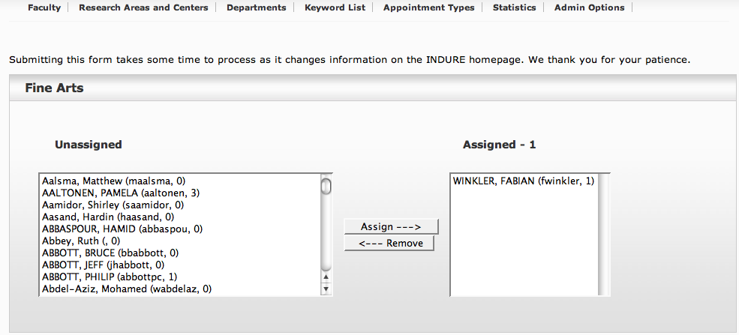
- Select faculty from the box on the left that you want to assign to the selected research area. Use the shift-click or CNTR-click to select multiple faculty members. All selected faculty will show as highlighted entries in the box on the left.
- Click on the “Assign” tab. In a few moments the selected faculty will appear in the box on the right. The assigned faculty members are removed from the box on the left.

Task 6: Add a faculty member

- Log into the database as described in Task 1 and go to Step 2. If you are already logged in then simply click on "Administration” and go to Step 3.
- Click on the tab labeled "Administration".
- Click on the “Faculty” tab.
- Click on the “Add Faculty/Admin” tab.
- Fill all entries for the faculty member you wish to add and click “Submit.” Important: The “User Name” entry must correspond to the login ID of the faculty member at your university. This is the ID that the added faculty member will use to login to INDURE.

Screen 11: New Faculty Information

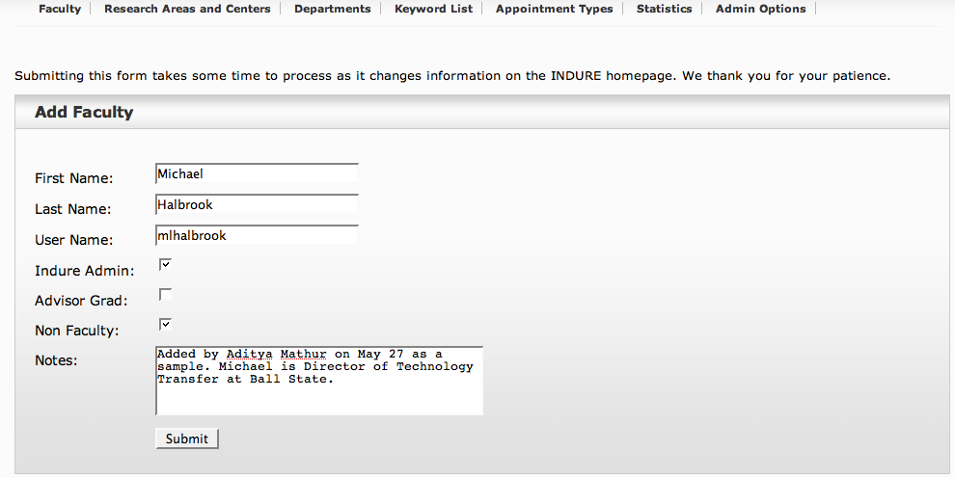

Task 7: Update faculty information: Admin status, Faculty status, Email, Keywords, Department, URL

- Log into the database as described in Task 1 and go to Step 2. If you are already logged in then simply click on "Administration” and go to Step 3.
- Click on the tab labeled "Administration".
- Click on the “Faculty” tab.
- In the box labeled “TERM” type the last name of the faculty member whose record you wish to update. Click the “Submit” button.

Screen 12: Faculty Data Edit
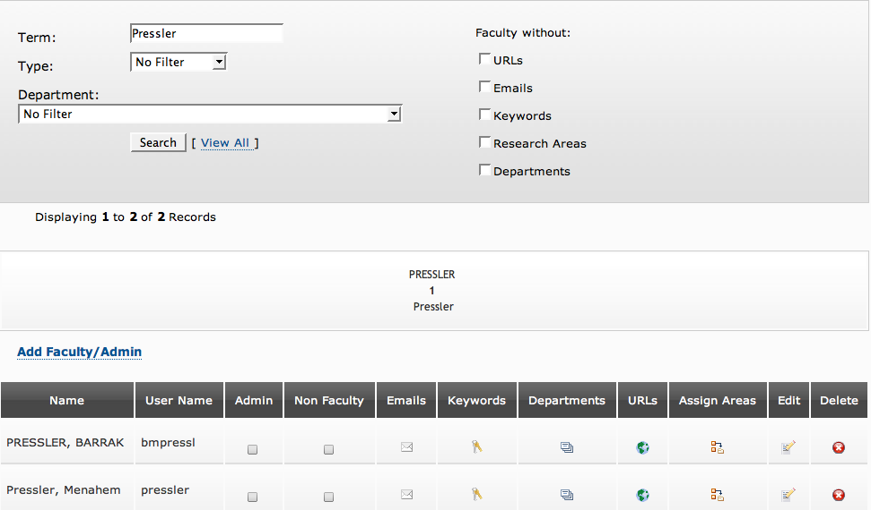

- You should now see a list of all entries with the last name that you typed in the previous step. Click on the appropriate tab in the entry corresponding to the faculty member whose data you wish to update. The tab labels are “Admin,” “Non Faculty,” “Emails,” “Keywords,” “Departments,” “URLs,” “Assign Areas,” “Edit,” and “Delete.”
- You should now be in a screen that corresponds to the tab you clicked in the previous step. Fill in the required information and click on “Submit.”
- Repeat steps 3 till 6 to update information on any other faculty member.

Task 8: View all assignments for faculty in your department.

- Log into the database as described in Task 1 and go to Step 2. If you are already logged in then simply click on "Administration” and go to Step 3.
- Click on the tab labeled "Administration".
- Scroll down the Department list and select the department you are interested in.
- Click the “Search” button and you will see a list of all faculty members in the elected department. Prior to clicking on the “Search” button you could narrow the list by checking attributes such as “URL” to indicate that you want list of only faculty in the selected department that no URL in INDURE.
- You may now select the faculty member of interest and view the associated data by clicking in the appropriate column.

Task 9: Add a Keyword List

- Log into the database as described in Task 1 and go to Step 2. If you are already logged in then simply click on "Administration” and go to Step 3.
- Click on the tab labeled "Administration".
- Click on the tab labeled “Keyword List.” Existing keyword lists in INDURE will now be displayed.

Screen: Add Keyword List
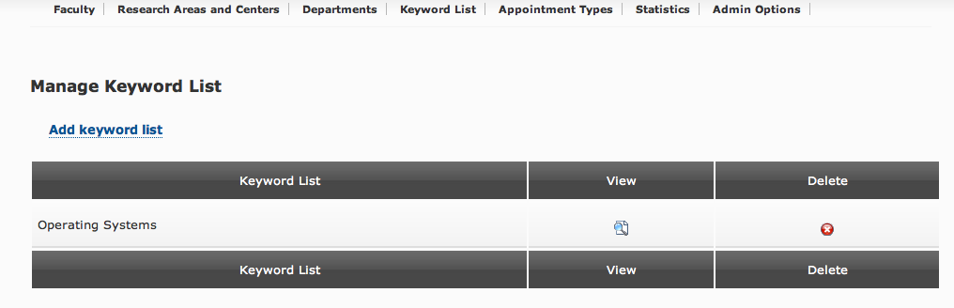

- Click on the tab labeled “Add Keyword List.”
- Type the name of the keyword list you want to add, and select the file that contains the corresponding list of keywords. This file must be a text only file (cannot be a pdf or a WORD doc file).

Screen 13: New Keyword List
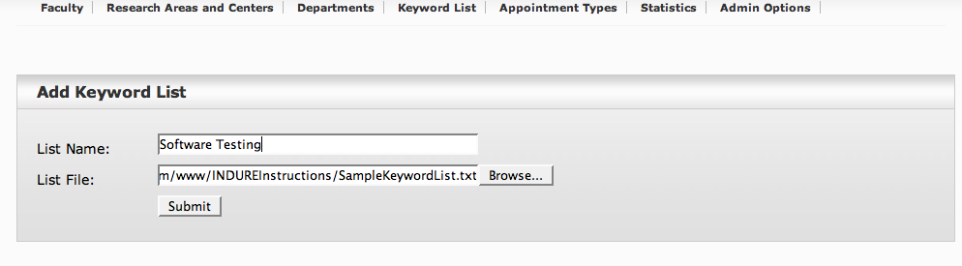
- Click “Submit.” You will now see the updated list of keyword lists.

Screen 14: Updated List of Keyword Lists

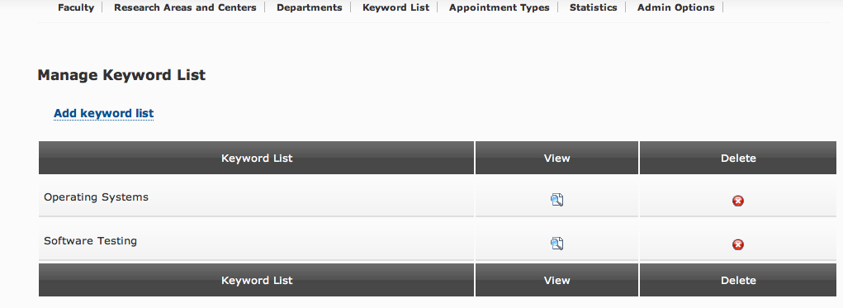
- You may view any keyword list by selecting the View icon next to the list.

Task 10: Add a new Appointment Type

- Log into the database as described in Task 1 and go to Step 2. If you are already logged in then simply click on "Administration” and go to Step 3.
- Click on the tab labeled "Administration".
- Click on the tab labeled “Appointment Types.” Existing appointment types will now be displayed.
- Click on the tab labeled “Add appointment type.” Enter the appointment type and click on “Submit.”

Screen 15: Adding an Appointment Type

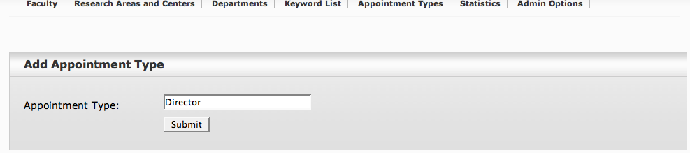

- The new appointment will now appear in the list of Appointment Types.

Screen 16: Updated List of Appointment Types

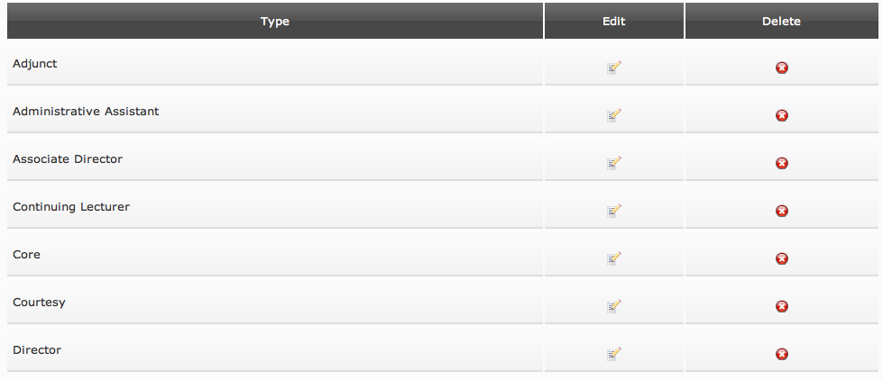

Task 11: Add a new College

- Log into the database as described in Task 1 and go to Step 2. If you are already logged in then simply click on "Administration” and go to Step 3.
- Click on the tab labeled "Administration".
- Click on the tab labeled Departments.
- Click on Add College.
- Select a campus from the pull down menu labeled Campus.
- Enter the exact name of the college you wish to add.
- Click on Submit.

Task 12: Map an existing Department to a College

- Log into the database as described in Task 1 and go to Step 2. If you are already logged in then simply click on "Administration” and go to Step 3.
- Click on the tab labeled "Administration".
- Click on the tab labeled Departments.
- Scroll down the list of universities and click on the Edit icon located to the right of the department you wish to map.
- Scroll down inside the box labeled School/College and select the college to which you wish to map the selected department.
- Please type in your name and date in the Notes box.
- Click on Submit.

<End of Instructions>

