How to Reserve 3151A
Step 1: Go to lab wiki http://wiki.cs.purdue.edu/cgvlab/ Internal page, login with your credentials.
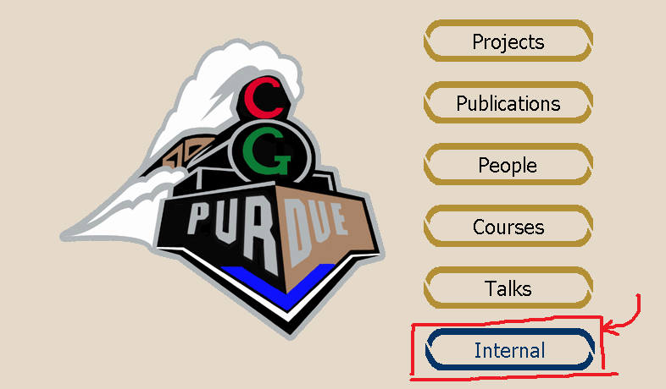

Step 2: Near the end of the page, click on 3151A Reservations.
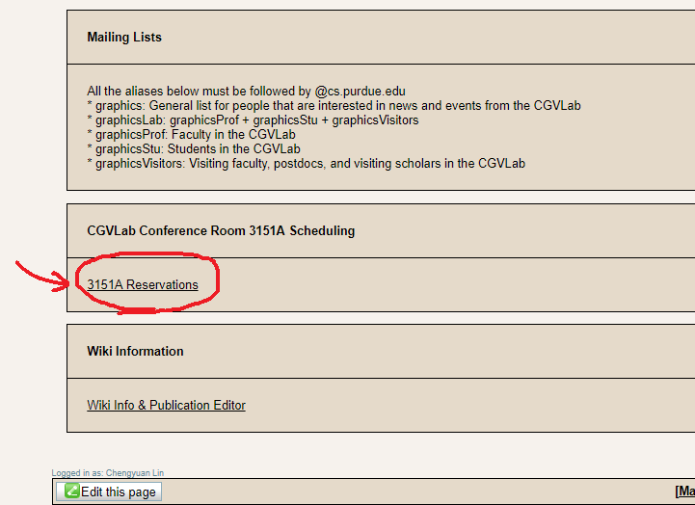

Step 3:
① For Recurring Reservations, click Edit ①. Please follow the format of “Day Time, End date; Title; Person in charge” and keep it sorted.
② For One Time Reservations, click Edit ②. Please follow the format of “Date, Time, Title” and keep it sorted.
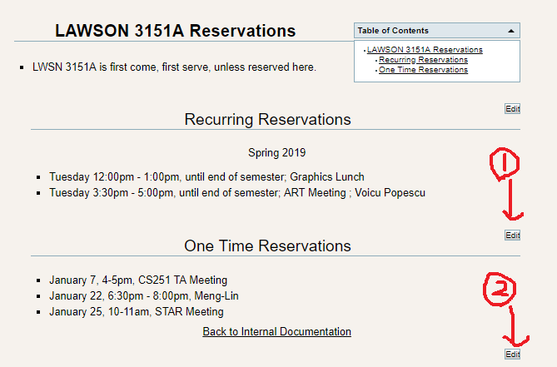

Questions? Contact song630@purdue.edu.

