How to Add a Paper to Lab Wiki
Step 1: Go to lab wiki http://wiki.cs.purdue.edu/cgvlab/ Internal page, login with your credentials.
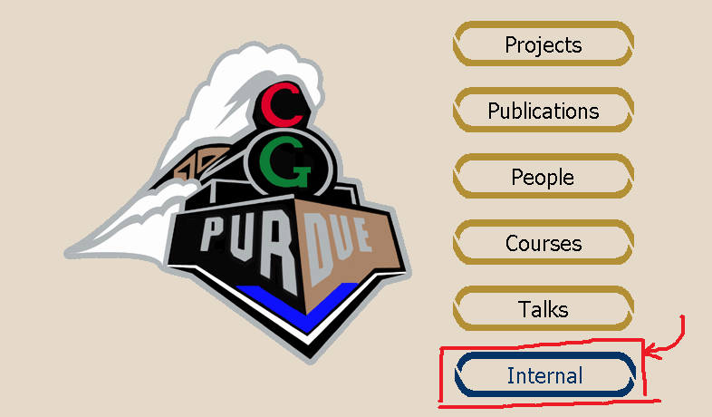

Step 2: At the bottom of the page, go to Publication Editor.
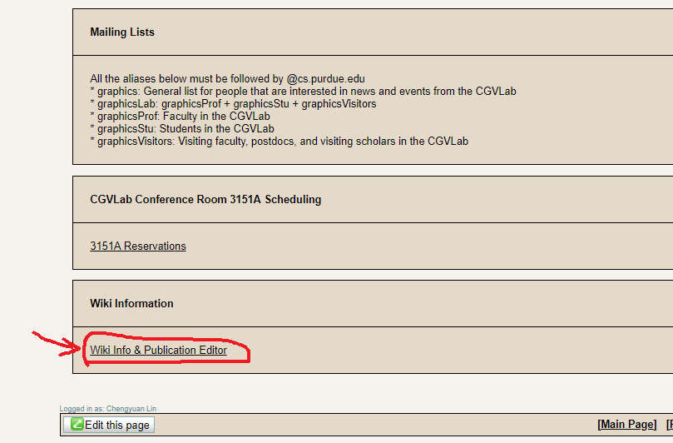

Step 3: (Optional) Add authors to the system.
Step 3a: Click Edit People.
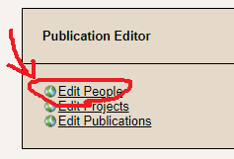

Step 3a: Go ahead and Add New Person. You can also Edit/Delete an author at this page.
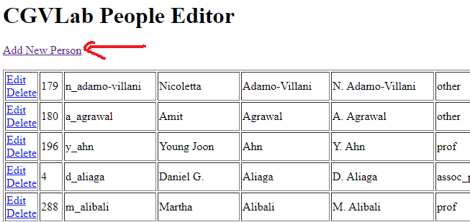

Step 3b: Leave Internal ID blank, fill out other fields, and Submit.
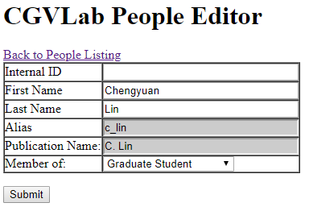

Step 4: Now it’s time to actually do some work, to add a paper.
Step 4a: Go Edit Publications.

Step 4b: Add New Publication.
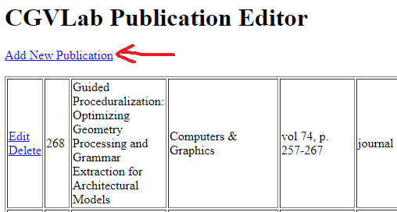

Step 4c: Leave Internal ID blank and fill in other fields (if applicable).
It’s recommended to have Year filled, as well as a link to the actual paper PDF URL.
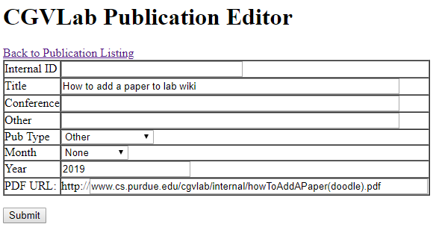

Step 4d: Edit the paper you just added.
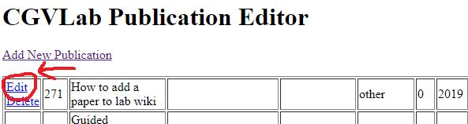

Step 4e:
① (Optional) Add Additional Files such as videos and supplemental material
② Add authors, or Current Members
③ (Optional) Add Part of Projects
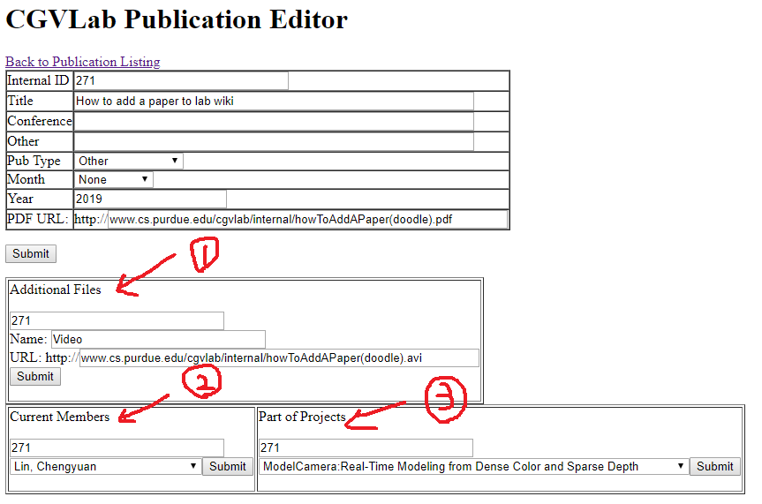

Questions? Contact song630@purdue.edu.

