https://www.cerias.purdue.edu/news_and_events/events/security_seminar/home/summer

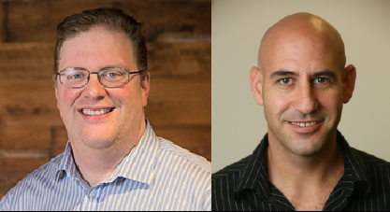

07/22/2020

"The Ghost in the Machine: Reconciling AI and Trust in the Connected World"
Sam Curry and Alon Kaufman - Cybereason / Duality Technologies

07/29/2020

"Network Awareness and Predictive Cyber Analytics"
Carter Bullard - QoSient

1/06/2019
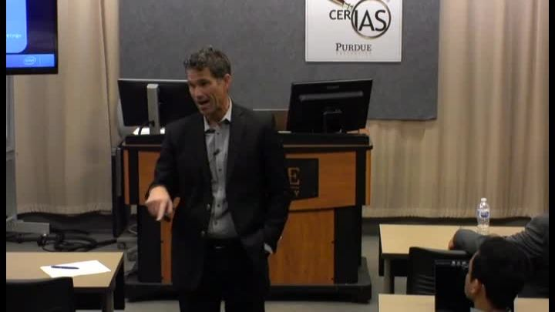

Securing the Internet of Things
James Cole - Intel

08/21/2019

10/02/2019
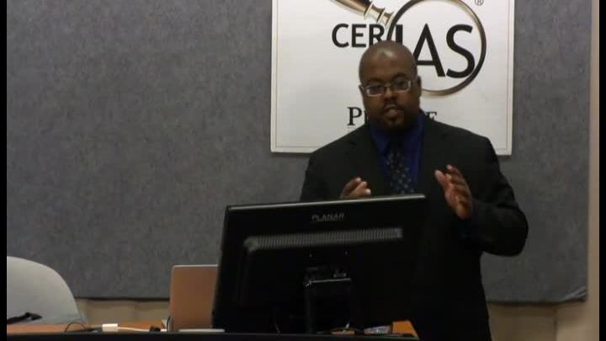

Moving Target Defense for a Serial Communication Protocol
Chris Jenkins - Sandia National Laboratories

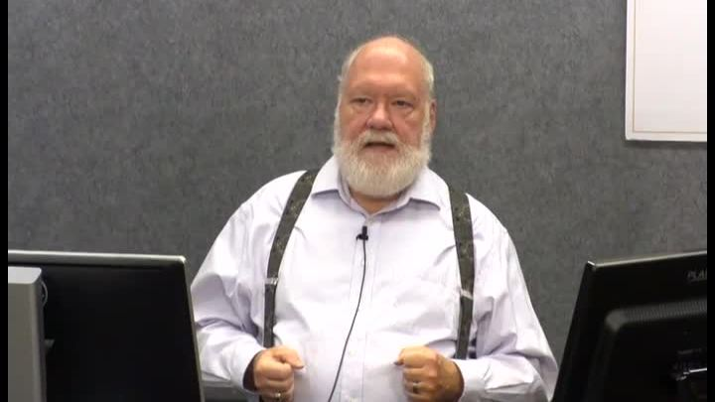

Rethinking Cyber Security
Eugene Spafford - Purdue University

02/06/2019
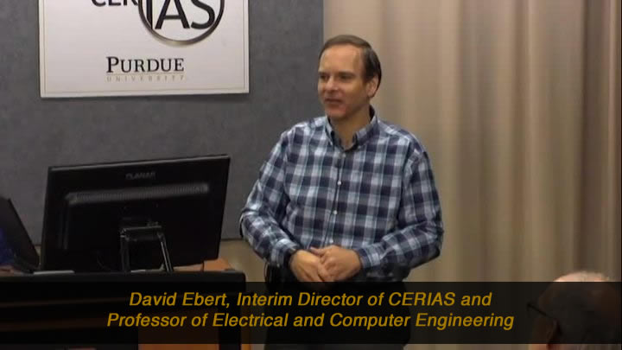

Trustable Information for Security Applications: Visual Analytics for Reliable, Effective Decision Making
David Ebert - Purdue University

01/23/2019
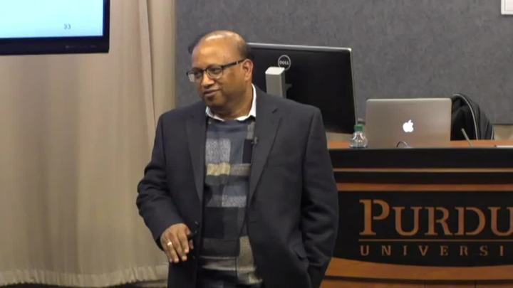

Secure Information Forwarding through Fragmentation in Delay- tolerant Networks
Sanjay Madria - Missouri University of Science and Technology
01/16/2019
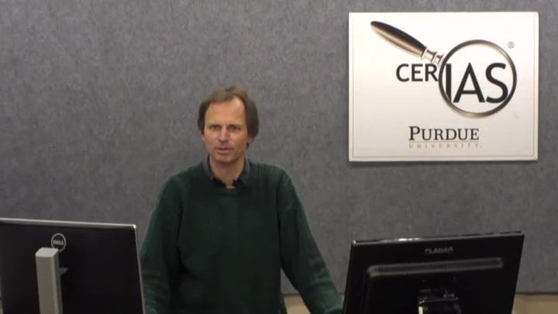

A Data Privacy Primer
Chris Clifton - Purdue University
01/20/2016

Privacy in Big Data: Thinking Outside the Anonymity/Confidentiality Box
Chris Clifton - Purdue University

