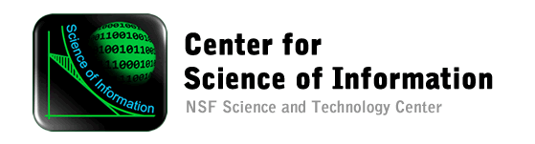
JListen Version 2.x Demo
April 26, 2012
Developers: Xuan Xu and Jiangnan Shangguan, undergraduate students, Department of Computer Science
Advisor: Aditya Mathur
Financial Support: Center for Science of Information and NSF.
Background
In all demonstrations today the primary purpose is to show that it is easy to listen to the data as it is generated and conclude how the data is changing. The first three demos sonify raw data while the last one sonifies the moving average of the data.
In all demos the data is being generated inside a Java program. However, the data could also be obtained from any sensor. For example, the data could be obtained from sensors connected to the human heart, analyzed by a Java program and sonified. Thus, one can “listen” to the changes in data and hence extract its “information content.” The demos are simple though more complex data sonifications are possible and will be programmed during Fall 2012.
Demo summary
Demo | Data variation | Event-Sound mapping
Sequential data | Listen to data that increases monotonically | DataPiano sound
sin function | Listen to sinusoidal data | DataPiano with strings in the background
Random Data | Liten to randomly varying data | DataPiano
Average | Listen to the average of data | DataPiano with strings as background
Acnowledgements
Thanks to the National Science Foundation, Professor Wojciech Szpankowski and Bob Brown for providing partial support for this project. Thanks to the Department of Computer Science for providing adequate space to conduct this research.

